// String methods : Compare method

public class Example2 {
public static void main(String[] args) {
String s1 = "I like eating food";
String s2 = "I like dresses";
String s3 = "I like eating food";
int result;

result = s1.compareTo(s2);//comparing s1 with s2
System.out.println(result);

result = s1.compareTo(s3);//comparing s1 with s3
System.out.println(result);

result = s3.compareTo(s2);//comparing s3 with s2
System.out.println(result);
}
}

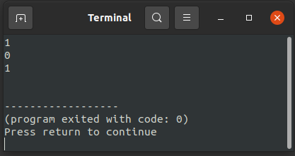
Output :

